Sri Lanka Institute of Information

Technology

**IT24100677**

**Samarathunga S.D.D**

**IT2120 - Probability and Statistics**

1)

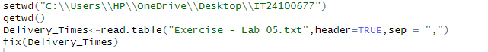

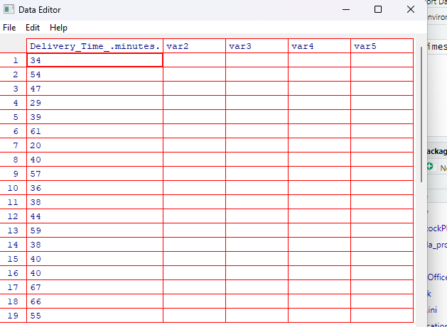

2)

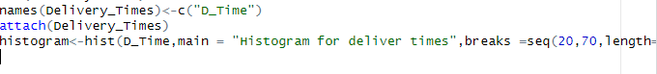

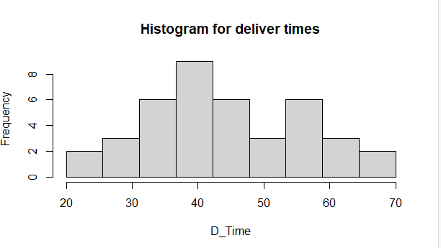

3)



4)



